Transaction Management Design Documentation

This document outlines the design of the Transaction Management system, which is a software application suite encompassing the CCTM (Credit Card Transaction Manager) and the RTCC (Real-Time Credit Cards). This is aimed at software maintenance engineers to get an understanding of the underlying architecture and design of the software.

System Overview
The purpose of the Transaction Management System is to authorize credit card transactions received from directly or indirectly from Single Space Parking Meters. Authorization can be performed using a variety of different authorization platforms, such as Montra or CreditCall. The two main systems, CCTM and RTCC, differ in the way that they acquire transactions – the CCTM acquires transactions from a database in a non-real-time manner, and the RTCC acquires transactions directly from the parking meter.
The system is implemented primarily in the managed .NET environment of C# using Visual Studio, since it is primarily a high-level application suite involving logic and user interaction.
An overview of the architecture of the entire software suite is shown in Figure 1. Since the CCTM and RTCC perform similar operations, they are treated only as logic and GUI extensions of what is called the Transaction Management System.
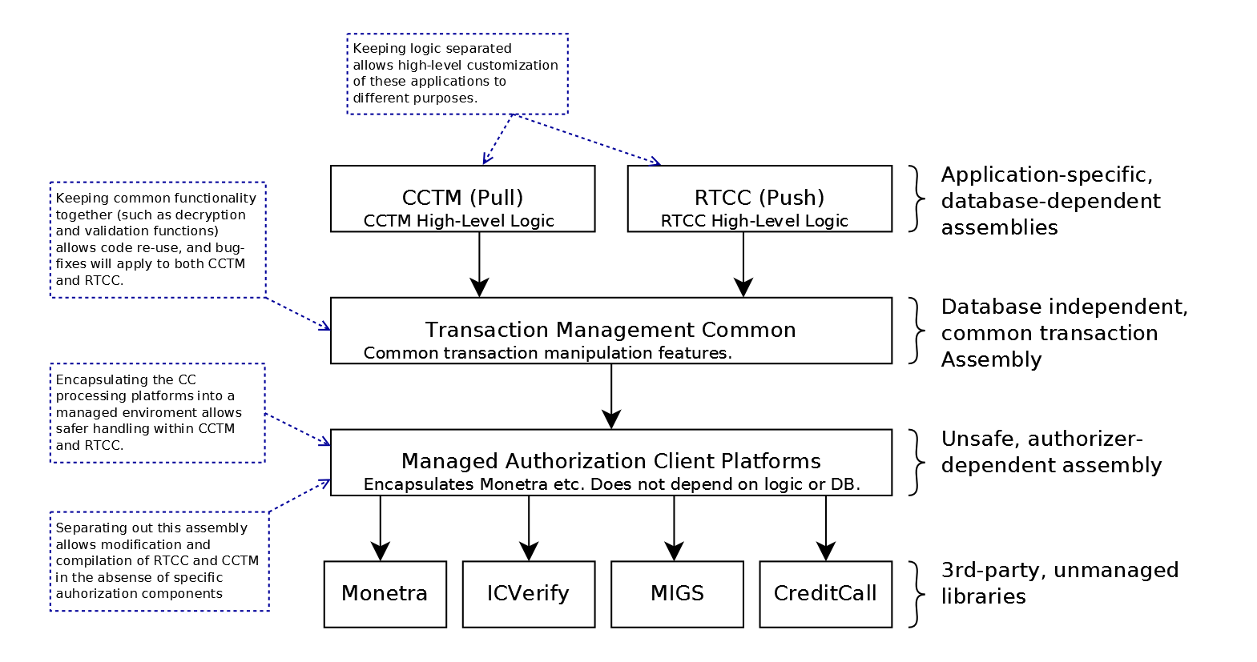Figure 1: Transaction Management Suite overview

CCTM
The CCTM is an application which retrieves unprocessed credit card transactions from a database and processes them using one of a number of authorization platforms. It is responsible for the high-level logic and behavior of the delayed (asynchronous) authorization, using common functionality provided by the Transaction Management Common library and its dependencies (see below).

RTCC
The RTCC is an application which synchronously processes credit card transactions provided in real-time from a parking meter. Similar to the CCTM, it is responsible for the high-level logic and behavior of the real-time authorization.

Transaction Management Common
This is a library which provides high-level functionality specific to the Transaction Management System (to process credit card transactions) but common to both the RTCC and CCTM. Although represented in Figure 1 as a single entity common to both the CCTM and RTCC, it may be deployed separately for the two applications. This library is independent of third-party modules, and allows software maintenance without the lengthy process of setting up the development environment with third-party modules.

Authorization Client Platforms
This is a library which provides functionality for authorizing credit cards using a predefined suite of authorization processors/platforms. As well as providing functionality common to credit card operations, this library provides a standardized, managed abstraction of the various authorization platforms.

Cryptographic Platforms
This is a library which exposes objects for handling the types of encryption used by the Transaction Management System for securing credit card information.

